Igneous pyroxene in Stardust

D. Jacob, H. Leroux, J. Stodolna and M.E. Zolensky.

Abstract:
A pyroxene terminal particle of Stardust has been studied transmission electron microscopy, including electron diffraction and energy dispersive X-ray microanalysis. A Ca-rich subgrain was found to contain lamellar intergrowth of pigeonite and diopside on (001). This microstructure is typical for an igneous process and formed by exsolution, i.e., a solid state transformation occurring during cooling. The periodicity of the lamellae is 25 nm and yields a cooling rate between 1 and 10 °C/h within the temperature interval 1350 and 1200 °C. This cooling rate is close to those of chondrules, a major component of most chondritic meteorites. Our observation show thus that some Stardust material experienced brief igneous processes similar to material found in the inner early solar system, and support the view of large radial mixing in the protosolar disk from to inner to outer regions before accretion.

The Stardust spacecraft successively returned to Earth dust from comet 81P/Wild 2 in January 2006. The preliminary examination of the samples showed that the samples contain abundant crystalline silicates (Zolensky et al., 2006). These silicates are mainly pyroxene and olivine (Zolensky et al., 2006), and are found preferentially as terminal particles of tracks into aerogel. Pyroxene and olivine are known to form at high temperature showing that Wild 2 comet is constituted at some significant fraction by minerals formed in the inner region of the solar nebulae which were redistributed by a radial transport in the protoplanetary disk (Brownlee et al., 2006; Zolensky et al., 2006). In this context it appears important to identify the process responsible of crystal formation. Several possibilities can be evoked. They include crystallisation by thermal annealing of amorphous interstellar precursors since the interstellar silicates are known to be amorphous, direct condensation in hot regions of the solar nebulae or crystallization from a melt during an igneous event such as, for instance, chondrule formation or volcanic activity at planetoid surface.

Among the high temperature minerals, pyroxenes are of a special interest because they are useful indicator for thermal and deformational events. The two pyroxene thermometry is a good help for constraining the equilibration temperature of igneous and metamorphic rocks. Basically this method is based on the distribution of Ca, Fe and Mg between orthopyroxene and clinopyroxene over the range of temperature 700-1500 °C (e.g., Ross and Huebner, 1979; Lindlsey 1983; Lindsley and Davidson, 1983; Davidson and Lindsley, 1985). Pyroxenes easily incorporate minor elements such as Na, Al, Ti, Cr and Mn and their partitioning in the crystallographic sites can be used as indicator about the conditions of the phase formation, as well as rare element Earth (REE) which are frequent to display zoning because of their slow diffusion rate (e.g. Papike 1996; Papike et al 2005). During slow cooling, in contrast to olivine, pyroxene grains frequently display complex exsolution textures which help deciphering the igneous history (e.g., At last pyroxenes are also known to record a wide variety of crystal defects, like for instance occurring during shock deformation (e.g., Leroux et al., 1994; Leroux et al., 2004).

Numbers of terminal Stardust particles are pyroxene-rich (Zolensky et al 2006). Because of their small size (typically less than a few micrometers) and their intimate mixing with compressed and/or melted aerogel, analytical transmission electron microscopy (ATEM) is an adapted tool to infer the structural state, the microchemistry and the microstructure of the Stardust samples. In this paper we report the occurrence of a Ca-rich pyroxene for which the microstructure is typical of crystallisation from a melt followed by subsolidus solid state exsolutions. The cooling rate is deduced, estimated within the range 1-10° C/h.

The studied sample comes from a bulbous track (figure 1) which terminates into two carrots at the terminal edge. The sample, about 5 µm in diameter, was extracted and prepared for TEM by ultramicrotomy at NASA/JSC and studied by ATEM at the University of Lille, France (supporting online material). The sample does not seem to have suffered thermal alteration. Only very minor melted material is found at the periphery, in contact with compressed aerogel. The sample is dominated by orthopyroxene and minor Ca-rich clinopyroxene. Compositions are given in the quadrilateral pyroxene diagram in figure 2. The main characteristic is the very low FeO content. Orthopyroxene contains a low density of crystal defects. A few dislocations are present as well as planar defects along the plane (100). The Ca-rich clinopyroxene grain is exsolved on (001) (figure 3a). The exsolution microstructure consists of coherent (001) lamellae with wavelength from 20 to 30 nm which are typical for alternation of Ca-rich and Ca-poor lamellae, i.e., diopside and pigeonite. The small thickness of the lamellae precluded the measurement of their composition. Only the average composition was obtained. Selected area electron diffraction patterns (figure 3b) confirm two distinct contributions, diopside with space group C2/c and pigeonite with space group P2₁/c. These two phases are distinguishable owing their different monoclinic lattice angle β, and by a slight difference in lattice parameter in the 100* and 001* directions. The diffraction pattern is dominated by a body centered C2/C structure for which only the reflections with h + k even are allowed, corresponding to the diopside, while the P2₁/c h+k odd reflections are significantly lower in intensity.

The phase assemblage is compatible with crystallization from a FeO-poor pyroxene-like parent melt. According to the Mg₂Si₂O₆-CaMgSi₂O₆ binary phase diagram (Figure 4), the primary crystallisation yields to the formation of orthenstatite and diopside. The bulk composition of the diopside grain correspond to a wollastonite (Wo) content of about 32 %, indicating a temperature of crystallization/equilibration of about 1400° C. During the subsequent cooling, the Ca solubility significantly increases in diopside while it only very slightly decreases in the orthoenstatite. Phase equilibration is volume diffusion controlled and cannot be achieved at lower temperatures over large distances. The primary diopside grains enter thus in a two phase field, namely pigeonite + diopside. During subsequent cooling pigeonite is exsolved in form of in form of coherent lamellae in the (001) plane, in a diopside matrix which enriches in Ca. The formation mechanism has been explained by spinodal-like process followed by coarsening (e.g., McCallister and Yung, 1977). In contrast, the enstatite component, because of the constant Ca solubility within the range of temperature 1200-1400° C does present exsolution microstructure.

Exsolution formation and coarsening in pyroxene is controlled by diffusion, which a time and temperature dependant process. By studying their coarsening, exsolution lamellae can be used to estimate the cooling rate of terrestrial and extraterrestrial rocks (e.g., Champness and Lorimer, 1971; Takeda et al 1975; Lally et al., 1975; Grove 1982; Schwartz and McCallum, 2005; Weinbruch and Muller 1995, Weinbruch et al. 2001; Watanabe et al., 1985; McCallister and Nord, 1981; Leroux et al 2004 – too many references here). According to Weinbruch et al 2001, the development of 001 lamellae requires cooling rates below 50 °C/h. It corresponds to the incubation period for which the spinodal process is completed. Lamellae coarsening have been calibrated with isothermal annealing or continuous cooling experiments (e.g., Grove 1982), including the iron-free clinopyroxene system (McCallister 1978; Weinbruch et al. 2003, 2006) close to the composition of the phase assemblage of the present Stardust sample. This calibration is based on the average periodicity of spacing of the (001) exsolution lamellae which tends to increase with time and temperature. Coarsening in isothermal growth experiments is described by an empirical equation λ^{n}(t) - λ₀^{n} = k (t - t₀), where k and n are empirical constants, λ₀ the average initial wavelength at t₀, λ(t) is the wavelength at time t. The exponent factor is found close to 3, indicating a volume diffusion controlled process (Weinbruch et al., 2003). For continuous cooling, the cooling rate can be estimated with time-temperature transformation (TTT) diagrams constructed with isothermal growths. This diagram is shown on figure 5. The average wavelength observed in the Stardust sample is 25 nm. When plotted in the TTT diagram, this value yields a cooling rate close to 1-10° C/h, within the temperature range 1350-1200° C. At lower temperature the diffusion is being to slow to account for coarsening. The main coarsening process occurred at T > 1200° C/h. The deduced cooling rate is quite comparable to the 25-33 nm obtained in an almost Fe-free clinopyroxene in granular olivine pyroxene chondrules from the Allende CV3 chondrite.

This result shows that chondrule-like material is not found only in the asteroid belt, but is present also at large distance form the inner region. Our observations agree with the fact radial mixing over large distances. Blabla Stardust … needs some significant input here.

Figure

Figure 1: Track #69 from which the terminal particle (arrowed) has been extracted at NASA-JSC. Mettre localisation du grain, voir faire montage de la NASA (si diponible)

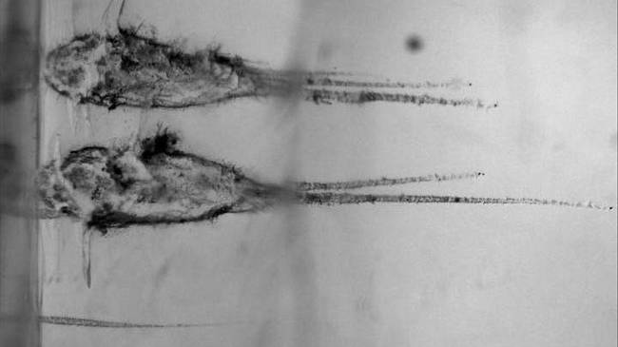

Figure 2: Pyroxene quadrilateral showing the composition of enstatite and diopside on the Stardust sample. The enstatite has a composition range from XXXX. For the diopside grain, the composition corresponds to the bulk composition of the grain. J’ai refait des mesures sur les profils, au Coeur des grains je trouve 32 % de Wo. Il faudrait aussi préparer un tableau d’analyse.

Be careful the red point is wrong. It is at 68% (and not at 72 as actually shown)
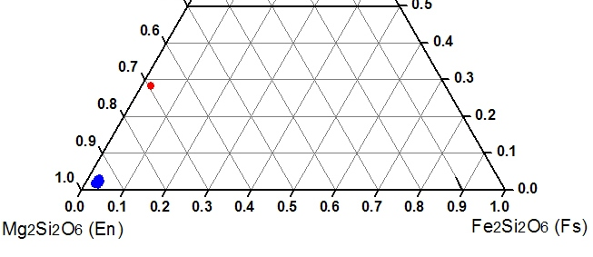

Figure 3: a) TEM bright field image showing the Ca-rich grain within enstatite. Note the presence of exsolution lamellae in 001. b) SAED pattern, zone axis XXX. The spots along the 110* are splited indicating the presence of an alternation of Ca-rich and Ca-poor clinopyroxene. This split corresponds to a Δβ of about 3° in the 100* direction.

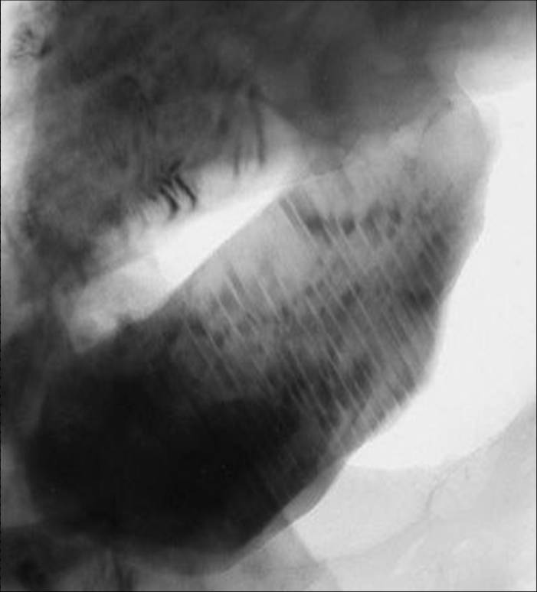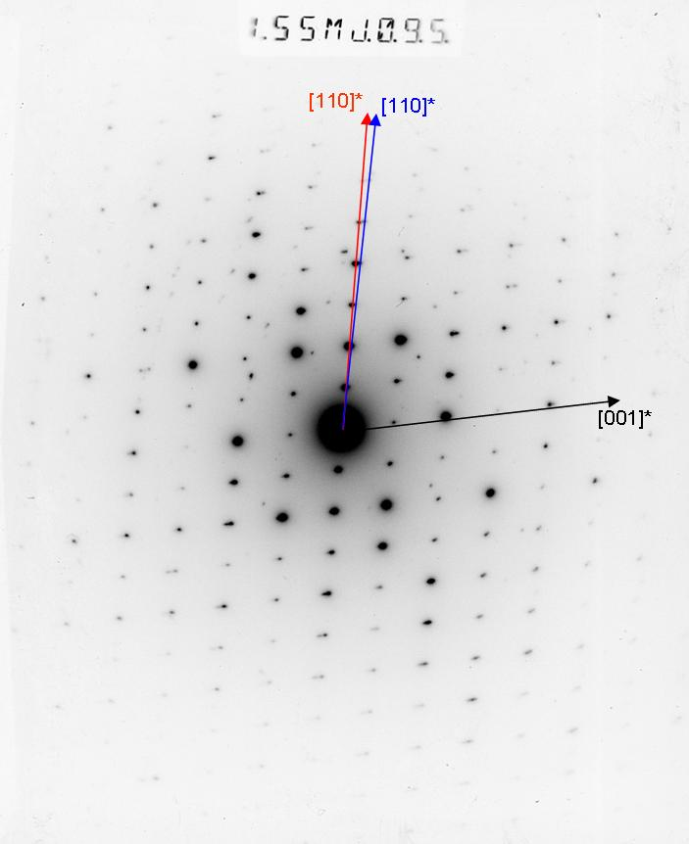

Figure 4: Schematic phase Mg₂Si₂O₆-CaMgSi₂O₆ binary phase diagram. Dashed light line indicates the detailed high temperature sub-liquidus sequence of crystallisation, which lead to the formation of enstatite and diopside. The miscibility gap is indicated by a strong dashed line. Subsolidus exsolution in diopside, highlighted by an arrow, takes place within the miscibility gap, in the two phase field diopside + pigeonite. Adapted from Carlson (1988).

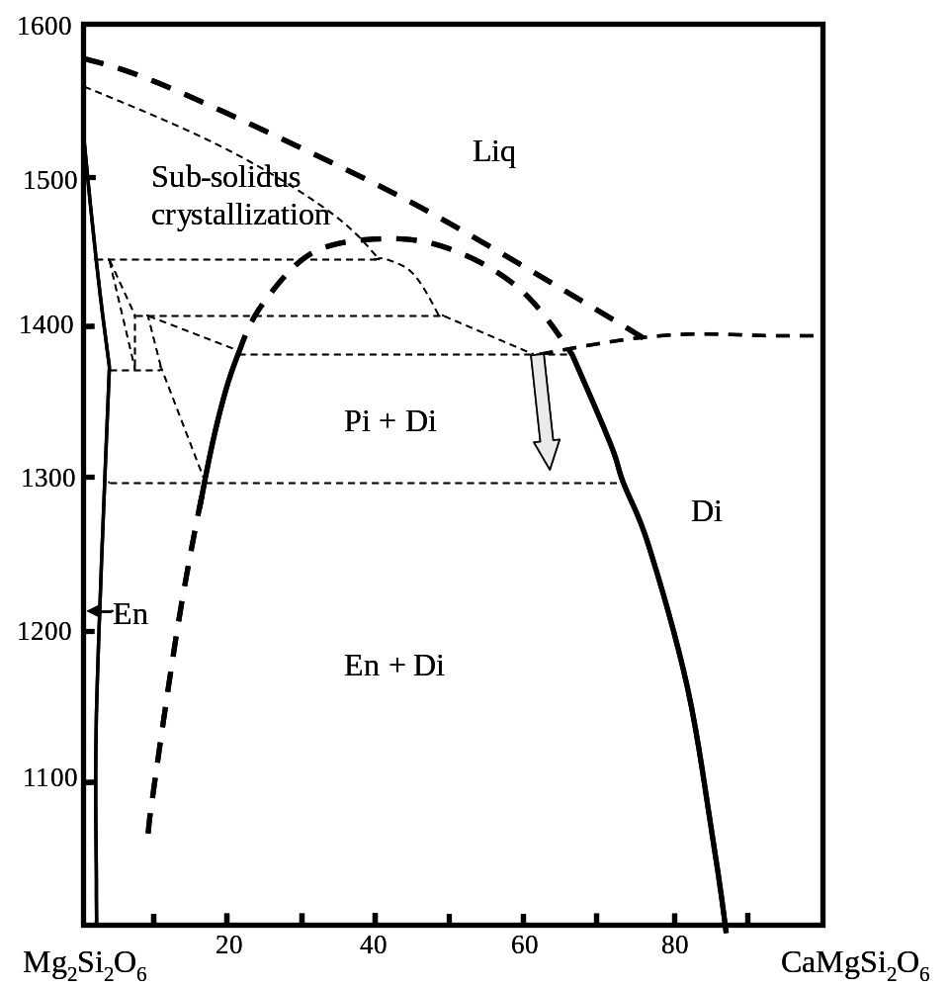
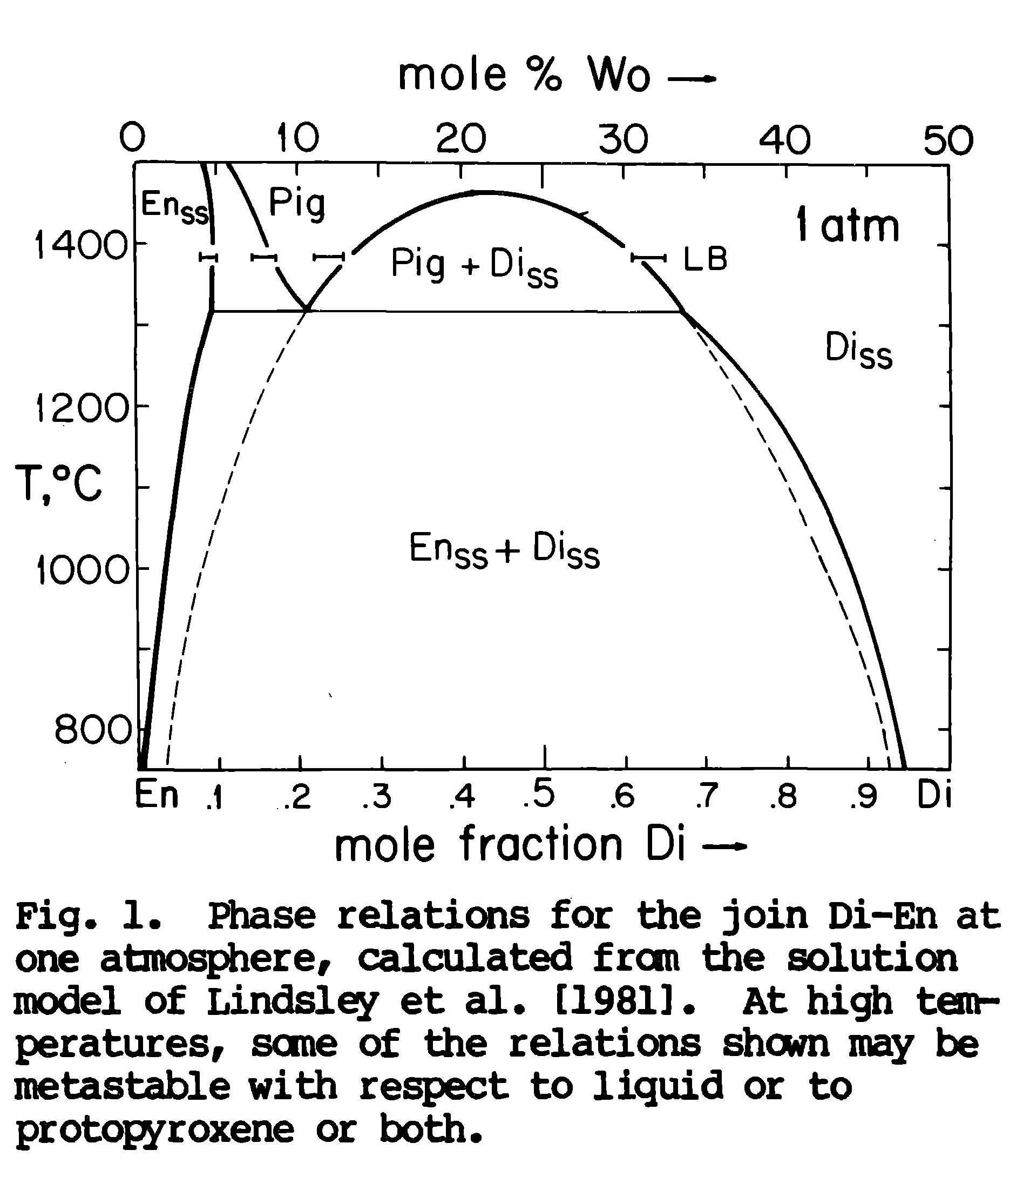
Figure 5: Time-temperature transformation (TTT) diagrams showing the evolution of the lamellae wavelength in function of time and temperature. Lamellae wavelengths are from Weinbruch et al 2003. They were deduced from isothermal annealing at T = 1300, 1200 and 1100° C of iron-free clinopyroxene. The average wavelength for the Stardust sample corresponds to the star. We reported continuous cooling rate at 1, 10 and 100° C/h. According to the phase diagram, the exsolution process must have started at 1350° C, and was almost completed at T = 1200° C (considered here as the closure temperature). The wavelength of 25 nm would correspond to a cooling rate within the rage 1-10° C/h. Construct also a corresponding figure as done by Weinbruch et al 1995 (see below).

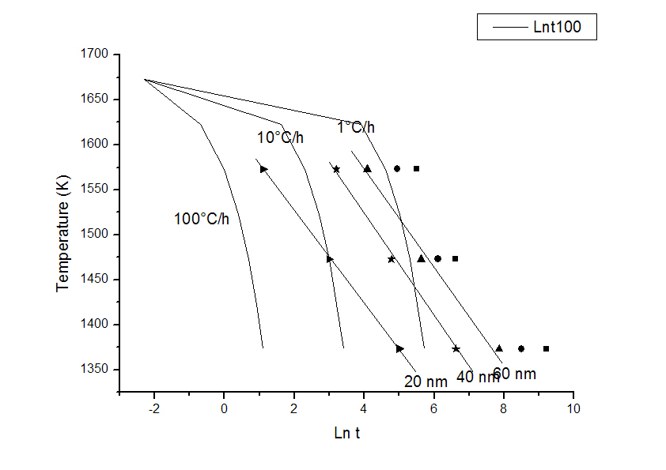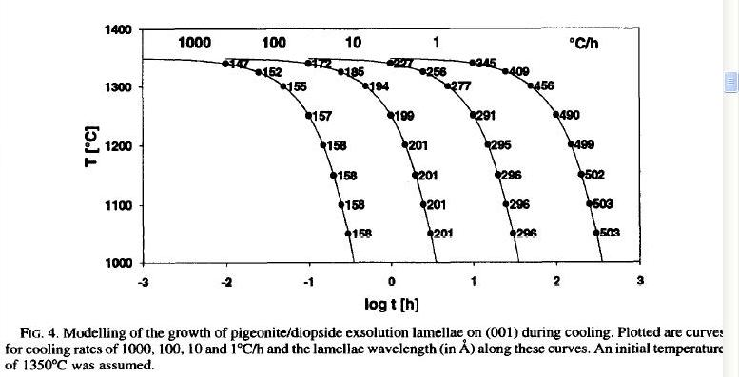
To be adapted. Here it is the figure from Weinbruch and Muller 1995

References:

Buseck P. R., Nord G. L. and Veblen D. R. (1980) Subsolidus phenomena in pyroxenes. In C.T. Prewitt, Ed., Pyroxenes, 7, p. 117-211. Reviews in Mineralogy, Mineralogical Society of America, Washington D.C.
Carlson W. D. (1988) Subsolidus phase equilibria on the forsterite-saturated join Mg₂Si₂O₆ -CaMgSi₂O₆ at atmospheric pressure. American Mineralogist 73, 232-241
Champness P. E. and Lorimer G. W. (1971) An electron microscopic study of a lunar pyroxene. Contribution to mineralogy and Petrology 33: 171-183.
Davidson, P M., and Lindsley, D.H. (1985) Thermodynamic analysis of quadrilateral pyroxenes. Part II: Model calibration from experiments and applications to geothermometry. Contributions to Mineralogy and Petrology 91: 390-404.
Lally J. S., Heuer A. H., Nord G. L. Jr. and Christie J. M. (1975) Subsolidus reactions in lunar pyroxenes: An electron petrographic study. Contribution to mineralogy and Petrology 51: XXX
Lindlsey D.H. and Andersen D. J. (1983). A two-pyroxene thermometer. Journal of Geophysical Research, 88, A887-A906.
McCallister, R. H. and Yund, R. A. (1977) Coherent exsolution in Fe-free pyroxenes. American Mineralogist, 62, 721-726
McCallister R.H. (1978) The coarsening kinetics associated with exsolution in an iron-free clinopyroxene. Contribution to mineralogy and Petrology 65, 327-331.
McCallister R. H. and Nord G. L. (1981) Subcalcic diopsides from kimberlites: Chemistry, exsolution microstructures, and thermal history. Contribution to mineralogy and Petrology 78: 118-125.
Müller W. F., Weinbruch S., Walter R. and Müller-Beneke G. (1995) Transmission electron microscopy of chondrule minerals in the Allende meteorite: constraints on the thermal and deformational history of granular olivine-pyroxene chondrules. Planetary and Space Science 43, 469-483
Papike J. J. (1996) Pyroxene as a recorder of cumulate formational processes in asteroids, Moon, Mars, Earth: reading the record with the ion microprobe. American Mineralogist, 81, 525.544.
Papike J. J., Karnet J. M. And Shearer C. K. (2005) COmpartaive planetary mineralogy : Valence state partitioning of Cr, Fe, Ti, and V among crystallographic sites in olivine, pyroxene, and spinel from planetary basalts. American mineralogist 90, 277-290.
Ross M. and Huebner J. S. (1979) Temperature-composition relationships between naturally occurring augite, pigeonite, and orthopyroxene at one bar pressure. American mineralogist 64, 1133-1155.
Schwartz J. M. and McCallum I. S. (2005) Comparative study of equilibrated and unequilibrated eucrites : Subsolidus thermal histories of Haraiya and Pasamonte. American mineralogist 90, 1871_1886.
Takeda H., Miyamoto M., Ishii T. and Lofgren G.E. (1975) Relative cooling rates of mare basalts at the Apollo 12 and 15 sites as estimated from pyroxene exsolution data. Proceedings of the 6th Lunar Planetary Science Conference, 987-996.
Watanabe S., Kitamura M., Morimoto N. (1985) A transmission electron microscope study of pyroxene chondrules in equilibrated L-group chondrites. Earth and Planetary Science Letters 72, 87-98.
Weinbruch S. and Müller W. F. (1995) Constraints on the cooling rates of chondrules from the microstructure of clinopyroxene and plagioclase. Geochimica et Cosmochimica Acta 59, 3221-3230.
Weinbruch S., Müller W. F. and Hewins R. H. (2001) A transmission electron microscope study of exsolution and coarsening in iron-bearing clinopyroxene from synthetic analogues of chondrules . Meteoritics & Planetary Science 36, 1237-1248
Weinbruch S., Styrsa V., Muller W. F. (2003) Exsolution and coarsening in iron-free clinopyroxene during isothermal annealing. Geochimica et Cosmochimica Acta 67, 5071-5082
Weinbruch S., Styrsa V., Dirsch T. (2006) The size distribution of exsolution lamellae in iron-free clinopyroxene. American Mineralogist 91, 551-559.
Zolensky M. E., Zega T. J., Yano H., Wirick S., Westphal A. J., Weisberg M. K., Weber I., Warren J. L., Velbel M. A., Tsuchiyama A., Tsou P., Toppani A., Tomioka N., Tomeoka K., Teslich N., Taheri M., Susini J., Stroud R., Stephan T., Stadermann F. J., Snead C. J., Simon S. B., Simionovici A., See T. H., Robert F., Rietmeijer F. J. M., Rao W., Perronnet M. C., Papanastassiou D. A., Okudaira K., Ohsumi K., Ohnishi I., Nakamura-Messenger K., Nakamura T., Mostefaoui S., Mikouchi T., Meibom A., Matrajt G., Marcus M. A., Leroux H., Lemelle L., Le L., Lanzirotti A., Langenhorst F., Krot A. N., Keller L. P., Kearsley A. T., Joswiak D., Jacob D., Ishii H., Harvey R., Hagiya K., Grossman L., Grossman J. N., Graham G. A., Gounelle M., Gillet Ph., Genge M. J., Flynn G., Ferroir T., Fallon S., Ebel D. S., Dai Z. R., Cordier P., Clark B., Chi M., Butterworth A. L., Brownlee D. E., Bridges J. C., Brennan S., Brearley A., Bradley J. P., Bleuet P., Bland P. A., and Bastien R. 2006. Mineralogy and petrology of comet 81P/Wild 2 nucleus samples. Science 314: 1735–1739.

